CSE 401 Computer Architecture

Winter 2018

Michael Smith

Hon Huynh

March 19th, 2018

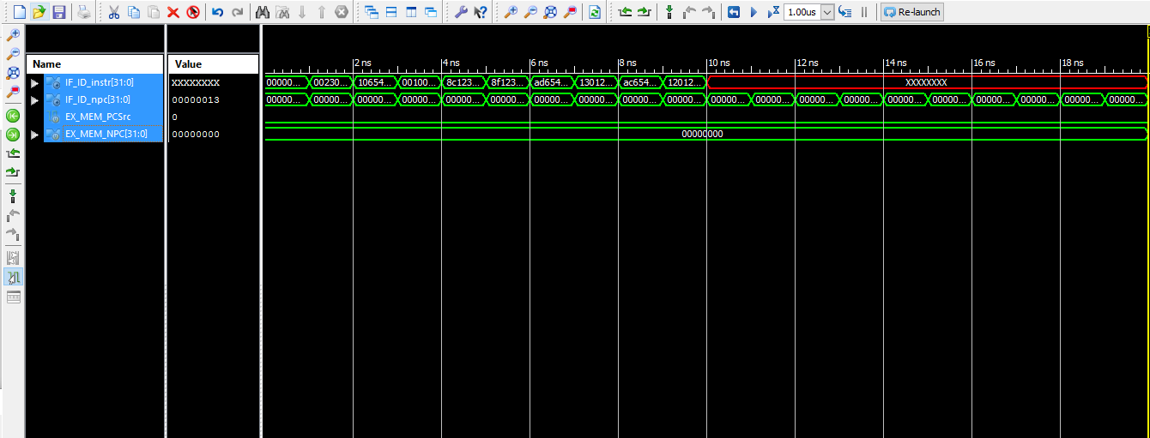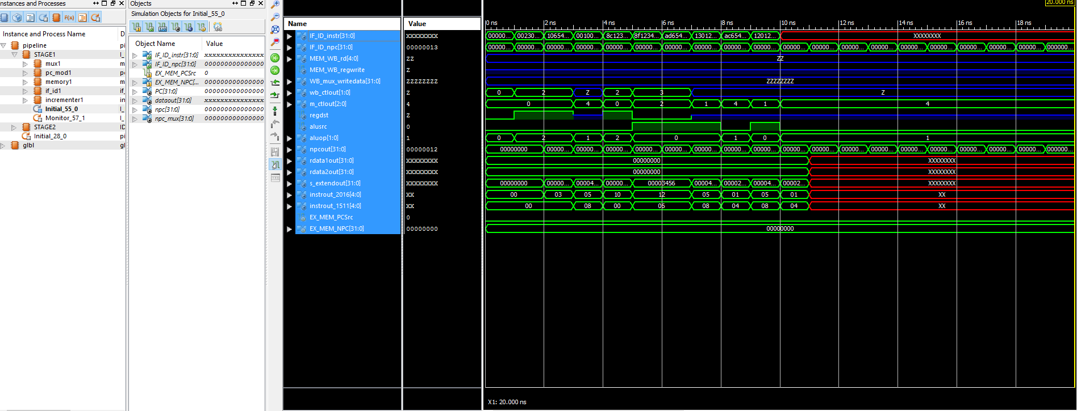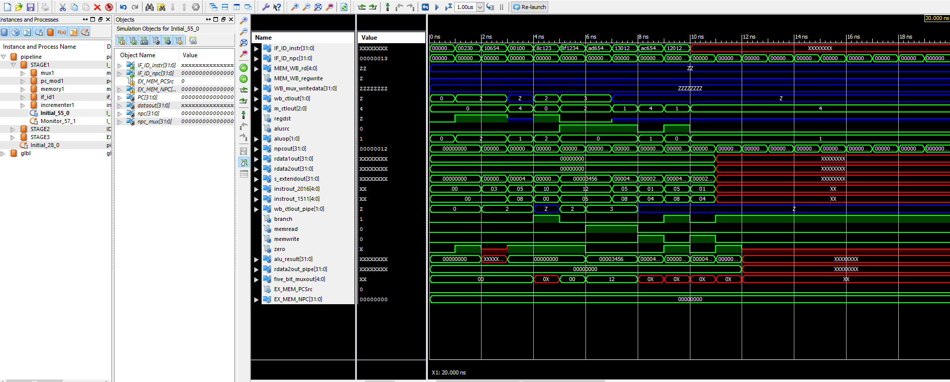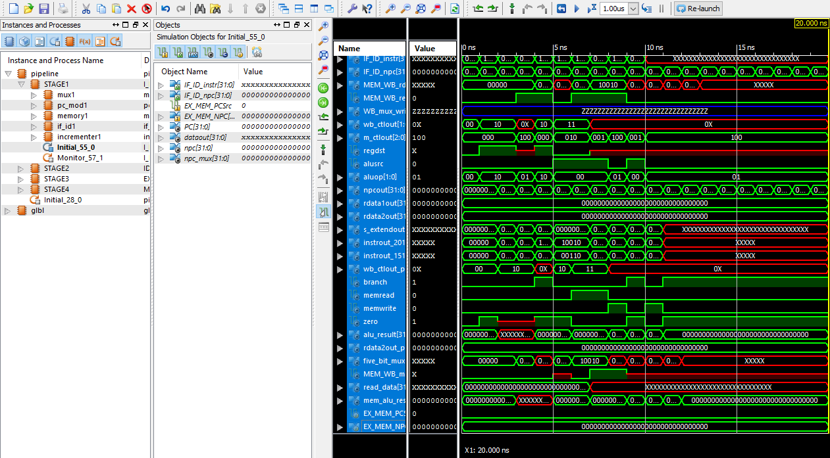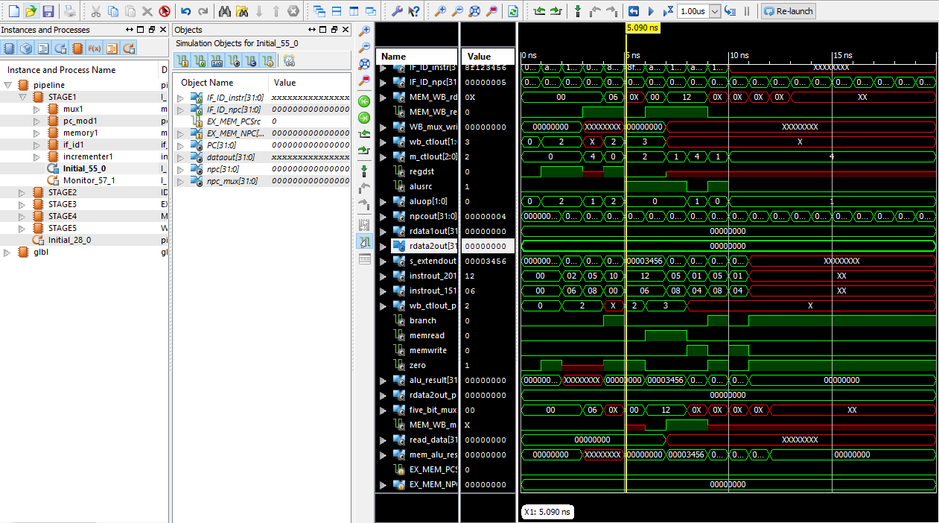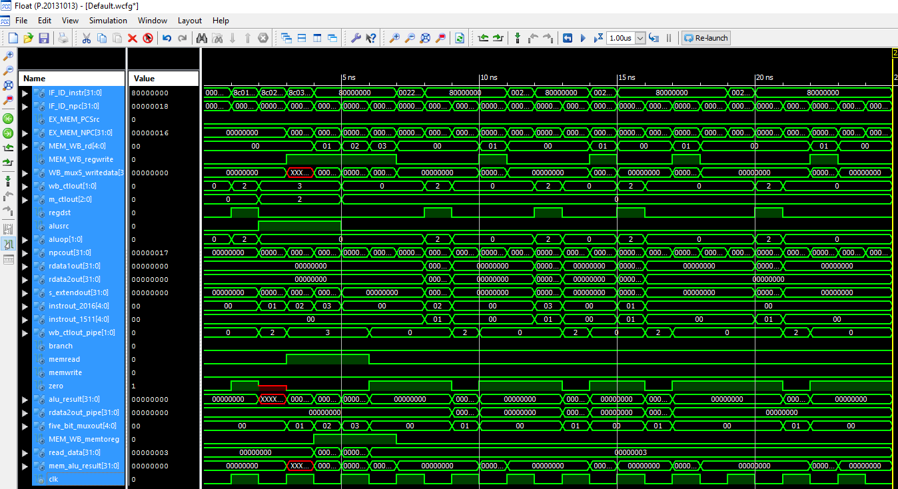

**PIPELINE:**

// Class: CSE 401 Computer Architecture  
// Term: WINTER2018  
// Name(s): Michael Smith  
// Hon Huynh  
// -*- Mode: Verilog -*-  
// Filename: pipeline.v  
  
module pipeline();  
  
 wire [31:0] IF_ID_instr, IF_ID_npc;  
 wire EX_MEM_PCSrc; // wire EX_MEM_PCSrc;  
 wire [31:0] EX_MEM_NPC; // wire [31:0] EX_MEM_NPC;  
  
 I_FETCH STAGE1(  
 .IF_ID_instr(IF_ID_instr),  
 .IF_ID_npc(IF_ID_npc),  
 .EX_MEM_PCSrc(EX_MEM_PCSrc),  
 .EX_MEM_NPC(EX_MEM_NPC) );  
  
// IDECODE  
 wire [4:0] MEM_WB_rd;  
 wire MEM_WB_regwrite;  
 wire [31:0] WB_mux_writedata;   
 wire [1:0] wb_ctlout;  
 wire [2:0] m_ctlout;  
 wire regdst, alusrc;  
 wire [1:0] aluop;   
 wire [31:0] npcout, rdata1out, rdata2out, s_extendout;  
 wire [4:0] instrout_2016, instrout_1511;  
  
 IDECODE STAGE2(  
 .IF_ID_instrout(IF_ID_instr),  
 .IF_ID_npcout(IF_ID_npc),  
 .MEM_WB_rd(MEM_WB_rd),  
 .MEM_WB_regwrite(MEM_WB_regwrite),  
 .WB_mux_writedata(WB_mux_writedata),  
 .wb_ctlout(wb_ctlout),  
 .m_ctlout(m_ctlout),  
 .regdst(regdst),  
 .alusrc(alusrc),  
 .aluop(aluop),  
 .npcout(npcout),  
 .rdata1out(rdata1out),  
 .rdata2out(rdata2out),  
 .s_extendout(s_extendout),  
 .instrout_2016(instrout_2016),  
 .instrout_1511(instrout_1511));  
   
// EXECUTE  
 wire [1:0] wb_ctlout_pipe;  
 wire branch, memread, memwrite;  
 wire zero;  
 wire [31:0] alu_result, rdata2out_pipe;  
 wire [4:0] five_bit_muxout;  
   
 EXECUTE STAGE3(  
 // inputs  
 .wb_ctl(wb_ctlout),  
 .m_ctl(m_ctlout),  
 .regdst(regdst),  
 .alusrc(alusrc),  
 .aluop(aluop),  
 .npcout(npcout),  
 .rdata1(rdata1out),  
 .rdata2(rdata2out),  
 .s_extendout(s_extendout),  
 .instrout_2016(instrout_2016),  
 .instrout_1511(instrout_1511),  
 // outputs  
 .wb_ctlout(wb_ctlout_pipe),  
 .branch(branch),   
 .memread(memread),   
 .memwrite(memwrite),  
 .zero(zero),  
 .alu_result(alu_result),  
 .rdata2out(rdata2out_pipe),  
 .add_result(EX_MEM_NPC),  
 .five_bit_muxout(five_bit_muxout));  
  
// MEMORY  
 wire MEM_WB_memtoreg;  
 wire [31:0] read_data, mem_alu_result;  
  
 MEMORY STAGE4(  
 // inputs  
 .wb_ctlout(wb_ctlout_pipe),  
 .branch(branch),  
 .memread(memread),  
 .memwrite(memwrite),  
 .zero(zero),  
 .alu_result(alu_result),  
 .rdata2out(rdata2out_pipe),  
 .five_bit_muxout(five_bit_muxout),  
 // outputs  
 .MEM_PCSrc(EX_MEM_PCSrc),  
 .MEM_WB_regwrite(MEM_WB_regwrite),  
 .MEM_WB_memtoreg(MEM_WB_memtoreg),  
 .read_data(read_data),  
 .mem_alu_result(mem_alu_result),  
 .mem_write_reg(MEM_WB_rd));  
   
// WRITEBACK  
 WRITEBACK STAGE5(  
 // inputs  
 .MEM_WB_memtoreg(MEM_WB_memtoreg),  
 .read_data(read_data),  
 .mem_alu_result(mem_alu_result),  
 // output  
 .WB_mux_writedata(WB_mux_writedata));   
 endmodule // pipeline

**LAB1**

**If_id:**

// Class: CSE 401 Computer Architecture

// Term: WINTER2018

// Name(s): Michael Smith

// Hon Huynh

// Lab #1: Instruction Fetch Stage

// -*- Mode: Verilog -*-

// Filename: if_id.v

module if_id(

output reg [31:0] instrout, // Output of IF/ID Instruction Register

npcout, // Output of IF/ID NPC Register

input wire [31:0] instr, // Input of IF/ID Instruction Register

npc // Input of IF/ID NPC Register

);

initial begin

instrout <= 32'b0;

npcout <= 32'b0;

end

always @* begin

#1;

instrout <= instr;

npcout <= npc;

end

endmodule // if_id

**Incrementer:**

// Class: CSE 401 Computer Architecture  
// Term: WINTER2018  
// Name(s): Michael Smith  
// Hon Huynh  
// Lab #1: Instruction Fetch Stage  
// -*- Mode: Verilog -*-  
// Filename: incr.v  
  
module incrementer (  
 input wire [31:0] pcin, // Input of incrementer  
 output wire [31:0] pcout // Output of incrementer  
 );  
   
 assign pcout = pcin + 1; // Increment PC by 1  
endmodule // incrementer

**Memory:**

// Class: CSE 401 Computer Architecture  
// Term: WINTER2018  
// Name(s): Michael Smith  
// Hon Huynh  
// Lab #1: Instruction Fetch Stage  
// -*- Mode: Verilog -*-  
// Filename: mem.v

module memory (  
 output reg [31:0] data, // Output of Instruction Memory  
 input wire [31:0] addr // Input of Instruction Memory  
 );  
  
// Register Declarations  
 reg [31:0] MEM[0:127]; // 128 words of 32-bit memory  
  
 integer i;  
  
// Initialize Registers  
 initial begin   
 $readmemb("etc/risc.txt",MEM);  
 end  
   
 always @(addr) begin  
 data <= MEM[addr];  
 end  
endmodule // memory

**Pc_mod:**

// Class: CSE 401 Computer Architecture  
// Term: WINTER2018  
// Name(s): Michael Smith  
// Hon Huynh  
// Lab #1: Instruction Fetch Stage  
// -*- Mode: Verilog -*-  
// Filename: pc_mod.v

module pc_mod (  
 output reg [31:0] PC, // Output of pc_mod  
 input wire [31:0] npc // Input of pc_mod  
 );  
  
 initial begin  
 PC <= 0;  
 end  
 always @ ( npc) begin  
 #1 PC <= npc;  
 end  
  
endmodule // pc_mod

**MUX:**

// Class: CSE 401 Computer Architecture  
// Term: WINTER2018  
// Name(s): Michael Smith  
// Hon Huynh  
// Lab #1: Instruction Fetch Stage  
// -*- Mode: Verilog -*-  
// Filename: mux.v  
  
module mux (  
 output wire [31:0] y, // Output of Multiplexer  
 input wire [31:0] a, // Input 1 of Multiplexer  
 b, // Input 0 of Multiplexer  
 input wire sel // Select Input  
 );  
   
 assign y = sel ? a : b;  
endmodule // mux

**Fetch:**

// Class: CSE 401 Computer Architecture  
// Term: WINTER2018  
// Name(s): Michael Smith  
// Hon Huynh  
// Lab #1: Instruction Fetch Stage  
// -*- Mode: Verilog -*-  
// Filename: ifetch.v  
  
module I_FETCH(  
 output wire [31:0] IF_ID_instr,  
 output wire [31:0] IF_ID_npc,  
 input wire EX_MEM_PCSrc,  
 input wire [31:0] EX_MEM_NPC  
 );  
   
 //signals  
 wire [31:0] PC;  
 wire [31:0] dataout;  
 wire [31:0] npc,npc_mux;  
  
 //instantiations  
 mux mux1 (.y(npc_mux),   
 .a(EX_MEM_NPC),   
 .b(npc),   
 .sel(EX_MEM_PCSrc));  
   
 pc_mod pc_mod1 (.PC(PC),   
 .npc(npc_mux));  
   
 memory memory1 (.data(dataout),  
 .addr(PC));  
   
 if_id if_id1 (.instrout(IF_ID_instr),  
 .npcout(IF_ID_npc),  
 .instr(dataout),   
 .npc(npc));  
   
 incrementer incrementer1 (.pcout(npc),   
 .pcin(PC));  
 initial begin  
 $display("Time\t PC\t npc\t dataout of MEM\t IF_ID_instr\t IF_ID_npc");  
 $monitor("%0d\t %0d\t %0d\t %h\t %h\t %0d", $time, PC, npc, dataout,IF_ID_instr,IF_ID_npc);  
 #22 $finish;  
 end   
  
endmodule // I_FETCH

**Lab2:**

**IDECODE:**

// Class: CSE 401 Computer Architecture

// Term: WINTER2018

// Name(s): Michael Smith

// Hon Huynh

/* IDECODE.v */

module IDECODE(

input wire [31:0] IF_ID_instrout,

input wire [31:0] IF_ID_npcout,

input wire [4:0] MEM_WB_rd,

input wire MEM_WB_regwrite,

input wire [31:0] WB_mux_writedata,

output wire [1:0] wb_ctlout,

output wire [2:0] m_ctlout,

output wire regdst, alusrc,

output wire [1:0] aluop,

output wire [31:0] npcout, rdata1out, rdata2out, s_extendout,

output wire [4:0] instrout_2016, instrout_1511

);

// signals

wire [3:0] ctlex_out;

wire [2:0] ctlm_out;

wire [1:0] ctlwb_out;

wire [31:0] readdat1, readdat2, signext_out;

// instantiations

control control2 (

// input

.opcode(IF_ID_instrout[31:26]),

// outputs

.EX(ctlex_out),

.M(ctlm_out),

.WB(ctlwb_out));

register register2 (

// input

.rs(IF_ID_instrout[25:21]),

.rt(IF_ID_instrout[20:16]),

.rd(MEM_WB_rd),

.writedata(WB_mux_writedata),

.regwrite(MEM_WB_regwrite),

// outputs

.A(readdat1),

.B(readdat2));

s_extend s_extend2 (

// input

.nextend(IF_ID_instrout[15:0]),

// output

.extend(signext_out));

id_ex id_ex2 (

// inputs

.ctlwb_out(ctlwb_out),

.ctlm_out(ctlm_out),

.ctlex_out(ctlex_out),

.npc(IF_ID_npcout),

.readdat1(readdat1),

.readdat2(readdat2),

.signext_out(signext_out),

.instr_2016(IF_ID_instrout[20:16]),

.instr_1511(IF_ID_instrout[15:11]),

// outputs

.wb_ctlout(wb_ctlout),

.m_ctlout(m_ctlout),

.regdst(regdst),

.alusrc(alusrc),

.aluop(aluop),

.npcout(npcout),

.rdata1out(rdata1out),

.rdata2out(rdata2out),

.s_extendout(s_extendout),

.instrout_2016(instrout_2016),

.instrout_1511(instrout_1511));

endmodule // IDECODE

**Control**

// Class: CSE 401 Computer Architecture

// Term: WINTER2018

// Name(s): Michael Smith

// Hon Huynh

/* control.v */

module control(

input wire [5:0] opcode,

output reg [3:0] EX,

output reg [2:0] M,

output reg [1:0] WB

);

parameter RTYPE = 6'b000000;

parameter LW = 6'b100011;

parameter SW = 6'b101011;

parameter BEQ = 6'b000100;

parameter NOP = 6'b100000;

initial begin

EX <= 4'b0000;

M <= 3'b000;

WB <= 2'b00;

end

always@* begin

case (opcode)

RTYPE:

begin

EX <= 4'b1100;

M <= 3'b000;

WB <= 2'b10;

end

LW:

begin

EX <= 4'b0001;

M <= 3'b010;

WB <= 2'b11;

end

SW:

begin

EX <= 4'bz001;

M <= 3'b001;

WB <= 2'b0z;

end

BEQ:

begin

EX <= 4'bz010;

M <= 3'b100;

WB <= 2'b0z;

end

NOP:

begin

EX <=4'b1000;

M <=3'b000;

WB <=2'b00;

end

default: $display ("Opcode not recognized.");

endcase

end

endmodule // control

**Register**

// Class: CSE 401 Computer Architecture  
// Term: WINTER2018  
// Name(s): Michael Smith  
// Hon Huynh  
/* reg.v */

module register(  
 input [4:0] rs,  
 input [4:0] rt,  
 input [4:0] rd,  
 input [31:0] writedata,  
 input regwrite,  
 output reg [31:0] A,  
 output reg [31:0] B  
 );  
  
// Register Declaration  
reg [31:0] REG [0:31]; //gives us 32 registers, each 32 bits long  
   
integer i;  
  
initial   
begin  
 A <= 0;  
 B <= 0;  
   
 // initialize our registers  
 for (i = 0; i < 32; i = i + 1)  
 REG[i] <= 0;  
end  
  
always @ *   
begin  
 A <= REG[rs];// Assign the rs index of REG to A ;  
 B <= REG[rt];// Assign the __ index of REG to B ;  
   
 // WRITE data using index rd  
 if ((rd!=0) & (regwrite==1))  
 REG[rd] <= writedata;  
end  
  
endmodule // register

**Extend**

// Class: CSE 401 Computer Architecture

// Term: WINTER2018

// Name(s): Michael Smith

// Hon Huynh

/* s_extend.v */

module s_extend(

input wire [15:0] nextend,

output reg [31:0] extend

);

always@ *

begin

// Replicate signed bit 16 times then cancatinate

extend <= {{16{nextend[15]}}, nextend[15:0]};

end

endmodule // s_extend

**ID_EX**

// Class: CSE 401 Computer Architecture

// Term: WINTER2018

// Name(s): Michael Smith

// Hon Huynh

/* id_ex.v */

module id_ex(

input wire [1:0] ctlwb_out,

input wire [2:0] ctlm_out,

input wire [3:0] ctlex_out,

input wire [31:0] npc, readdat1, readdat2, signext_out,

input wire [4:0] instr_2016, instr_1511,

output reg [1:0] wb_ctlout,

output reg [2:0] m_ctlout,

output reg regdst, alusrc,

output reg [1:0] aluop,

output reg [31:0] npcout, rdata1out, rdata2out, s_extendout,

output reg [4:0] instrout_2016, instrout_1511

);

initial

begin

// Initialize outputs to 0

wb_ctlout <= 2'b0;

m_ctlout <= 3'b0;

regdst <= 1'b0;

aluop <= 2'b0;

alusrc <= 1'b0;

npcout <= 32'b0;

rdata1out <= 32'b0;

rdata2out <= 32'b0;

s_extendout <= 32'b0;

instrout_2016 <= 5'b0;

instrout_1511 <= 5'b0;

end

always @ *

begin

// Inputs wired to corresponding outputs

#1;

wb_ctlout <= ctlwb_out;

m_ctlout <= ctlm_out;

regdst <= ctlex_out[3];

aluop <= ctlex_out[2:1];

alusrc <= ctlex_out[0];

npcout <= npc;

rdata1out <= readdat1;

rdata2out <= readdat2;

s_extendout <= signext_out;

instrout_2016 <= instr_2016;

instrout_1511 <= instr_1511;

end

endmodule //id_ex

**LAB3**

**Execute:**

// Class: CSE 401 Computer Architecture

// Term: WINTER2018

// Name(s): Michael Smith

// Hon Huynh

/* execute.v */

module EXECUTE(

input wire [1:0] wb_ctl,

input wire [2:0] m_ctl,

input wire regdst, alusrc,

input wire [1:0] aluop,

input wire [31:0] npcout, rdata1, rdata2, s_extendout,

input wire [4:0] instrout_2016, instrout_1511,

output wire [1:0] wb_ctlout,

output wire branch, memread, memwrite,

output wire zero,

output wire [31:0] alu_result, rdata2out, add_result,

output wire [4:0] five_bit_muxout

);

// signals

wire [31:0] adder_out, b, aluout;

wire [4:0] muxout;

wire [2:0] control;

wire aluzero;

// instantiations

adder adder1(

// output

.add_out(adder_out),

// inputs

.add_in2(s_extendout),

.add_in1(npcout));

mux mux2(

// output

.y(b),

// inputs

.a(s_extendout),

.b(rdata2),

.sel(alusrc));

alu alu1(

// inputs

.a(rdata1),

.b(b),

.control(control),

// outputs

.result(aluout),

.zero(aluzero));

alu_control alu_control1(

// inputs

.funct(s_extendout[5:0]),

.aluop(aluop),

// output

.select(control));

bottom_mux bottom_mux1(

// output

.y(muxout),

// inputs

.a(instrout_1511),

.b(instrout_2016),

.sel(regdst));

ex_mem ex_mem1(

//inputs

.ctlwb_out(wb_ctl),

.ctlm_out(m_ctl),

.adder_out(adder_out),

.aluzero(aluzero),

.aluout(aluout),

.readdat2(rdata2),

.muxout(muxout),

// outputs

.wb_ctlout(wb_ctlout),

.branch(branch),

.memread(memread),

.memwrite(memwrite),

.add_result(add_result),

.zero(zero),

.alu_result(alu_result),

.rdata2out(rdata2out),

.five_bit_muxout(five_bit_muxout));

endmodule // IEXECUTE

**ADDER:**

// Class: CSE 401 Computer Architecture

// Term: WINTER2018

// Name(s): Michael Smith

// Hon Huynh

/* adder.v */

module adder(

output reg [31:0] add_out,

input [31:0] add_in1, add_in2

);

always@ *

begin

add_out <= add_in1 + add_in2;

end

endmodule // adder

**ALU**

// Class: CSE 401 Computer Architecture

// Term: WINTER2018

// Name(s): Michael Smith

// Hon Huynh

/* alu.v */

module alu(

input wire [31:0] a,

input wire [31:0] b,

input wire [2:0] control,

output reg [31:0] result,

output wire zero

);

parameter ALUadd = 3'b010,

ALUsub = 3'b110,

ALUand = 3'b000,

ALUor = 3'b001,

ALUslt = 3'b111;

// Handles negative inputs

wire sign_mismatch;

assign sign_mismatch = a[31] ^ b[31];

initial

result <= 0;

always@*

case(control)

ALUadd: result = a + b;

ALUsub: result = a - b;

ALUand: result = a && b;

ALUor: result = a || b;

ALUslt: result = a < b ? 1 - sign_mismatch : 0 + sign_mismatch;

default: result = 32'bX;

endcase

assign zero = (result==0) ? 1'b1 : 1'b0;

/* If result is 0, assign it true (1).

Otherwise, assign it false (0) */

endmodule // alu

**Bottom MUX:**

// Class: CSCI 401 Computer Architecture  
// Term: WINTER2018  
// Name(s): Michael Smith  
// Hon Huynh  
/* bottom_mux */

module bottom_mux(  
 output wire [4:0] y, // Output of Multiplexer  
 input wire [4:0] a, // Input 1 of Multiplexer  
 b, // Input 0 of Multiplexer  
 input wire sel // Select Input  
 );  
   
 assign y = sel ? a : b;  
endmodule // bottom_mux

**EX_MEM:**

// Class: CSCI 401 Computer Architecture  
// Term: WINTER2018  
// Name(s): Michael Smith  
// Hon Huynh  
/* ex_mem.v */

module ex_mem(  
 input wire [1:0] ctlwb_out,  
 input wire [2:0] ctlm_out,  
 input wire [31:0] adder_out,  
 input wire aluzero,  
 input wire [31:0] aluout, readdat2,  
 input wire [4:0] muxout,  
 output reg [1:0] wb_ctlout,  
 output reg branch, memread, memwrite,  
 output reg [31:0] add_result,  
 output reg zero,  
 output reg [31:0] alu_result, rdata2out,  
 output reg [4:0] five_bit_muxout  
 );  
  
 initial begin  
 // Initialize outputs to 0  
 wb_ctlout <= 0;   
 branch <= 0; memread <= 0; memwrite <= 0;  
 add_result <= 0;  
 zero <= 0;  
 alu_result <= 0; rdata2out <= 0;  
 five_bit_muxout <= 0;  
 end  
  
 always@* begin  
 // Inputs wired to corresponding outputs  
 #1;  
 wb_ctlout <= ctlwb_out;  
 branch <= ctlm_out[2];   
 memread <= ctlm_out[1];  
 memwrite <= ctlm_out[0];   
 add_result <= adder_out;   
 zero <= aluzero;  
 alu_result <= aluout;  
 rdata2out <= readdat2;  
 five_bit_muxout <= muxout;  
 end  
endmodule // ex_mem

**LAB4**

**Memory:**

// Class: CSE 401 Computer Architecture  
// Term: WINTER2018  
// Name(s): Michael Smith  
// Hon Huynh  
/* MEMORY.v */

module MEMORY(  
 input wire [1:0] wb_ctlout,  
 input wire branch, memread, memwrite,  
 input wire zero,  
 input wire [31:0] alu_result, rdata2out,  
 input wire [4:0] five_bit_muxout,  
 output wire MEM_PCSrc,  
 output wire MEM_WB_regwrite, MEM_WB_memtoreg,  
 output wire [31:0] read_data, mem_alu_result,  
 output wire [4:0] mem_write_reg  
 );  
  
 // signals  
 wire [31:0] read_data_in;  
   
 // instantiations  
 AND AND_4(  
 // inputs  
 .membranch(branch),  
 .zero(zero),  
 // output   
 .PCSrc(MEM_PCSrc));  
   
 data_memory data_memory4(  
 //inputs  
 .addr(alu_result),  
 .write_data(rdata2out),  
 .memwrite(memwrite),  
 .memread(memread),  
 // output  
 .read_data(read_data_in));  
   
 mem_wb mem_wb4(  
 //inputs  
 .control_wb_in(wb_ctlout),  
 .read_data_in(read_data_in),  
 .alu_result_in(alu_result),  
 .write_reg_in(five_bit_muxout),  
 // outputs  
 .regwrite(MEM_WB_regwrite),  
 .memtoreg(MEM_WB_memtoreg),  
 .read_data(read_data),  
 .mem_alu_result(mem_alu_result),  
 .mem_write_reg(mem_write_reg));  
endmodule // MEMORY

**AND_4:**

`timescale 1ns / 1ps  
// Class: CSE 401 Computer Architecture  
// Term: WINTER2018  
// Name(s): Michael Smith  
// Hon Huynh  
/* and.v */

module AND(  
 input wire membranch, zero,  
 output wire PCSrc  
 );  
  
 assign PCSrc = membranch && zero;  
endmodule // and

**DATA_MEM:**

// Class: CSE 401 Computer Architecture  
// Term: WINTER2018  
// Name(s): Michael Smith  
// Hon Huynh

/* data_memory.v */

module data_memory (  
 output reg [31:0] read_data,

input wire [31:0] addr, // Memory Address  
 input wire [31:0] write_data, // Memory Address Contents  
 input wire memwrite, memread  
 );  
  
 // Register Declaration  
 reg [31:0] DMEM[0:255]; // 256 words of 32-bit memory  
  
 integer i;  
   
 initial begin  
 read_data <= 0;  
   
 // Initialize DMEM[0-5] from data.txt  
 $readmemb("etc/data.txt",DMEM);  
   
 end  
   
 always@(addr)begin  
 if ((memread == 1) && (memwrite == 0))  
 // Read data  
 read_data <= DMEM[addr];  
 if ((memwrite == 1) && (memwrite == 0))  
 // Write data  
 DMEM[addr] <= write_data;  
 end  
endmodule // data_memory

**MEM_WB:**

// Class: CSE 401 Computer Architecture  
// Term: WINTER2018  
// Name(s): Michael Smith  
// Hon Huynh  
/* mem_wb.v */

module mem_wb(  
 input wire [1:0] control_wb_in,  
 input wire [31:0] read_data_in, alu_result_in,  
 input wire [4:0] write_reg_in,  
 output reg regwrite, memtoreg,  
 output reg [31:0] read_data, mem_alu_result,  
 output reg [4:0] mem_write_reg  
 );  
  
initial begin  
 // Initialize outputs to 0  
 regwrite <= 0;  
 memtoreg <= 0;  
 read_data <= 0;  
 mem_alu_result <= 0;  
 mem_write_reg <= 0;  
   
end  
  
always@* begin  
 // Inputs wired to corresponding outputs  
 #1;  
 regwrite <= control_wb_in[1];  
 memtoreg <= control_wb_in[0];  
 read_data <= read_data_in;  
 mem_alu_result <= alu_result_in;  
 mem_write_reg <= write_reg_in;  
end  
endmodule // mem_wb

**LAB5**

**WRITEBACK:**

// Class: CSE 401 Computer Architecture  
// Term: WINTER2018  
// Name(s): Michael Smith  
// Hon Huynh  
/* WRITEBACK.v */

module WRITEBACK(  
 input wire MEM_WB_memtoreg,  
 input wire [31:0] read_data, mem_alu_result,  
 output wire [31:0] WB_mux_writedata  
 );  
   
 // instantiation  
 mux mux3(  
 // output  
 .y(WB_mux_writedata),  
 // inputs  
 .sel(MEM_WB_memtoreg),  
 .a(read_data),  
 .b(mem_alu_result)   
 );  
endmodule // WRITEBACK

**REG_TEST.v:**

`timescale 1ns / 1ps  
// Class: CSE 401 Computer Architecture  
// Term: WINTER2018  
// Name(s): Michael Smith  
// Hon Huynh  
// Mode: reg_test

module reg_test;  
 wire [31:0] data_rs, data_rt;  
  
 reg [4:0] addr_rs, addr_rt, write_addr;  
 reg [31:0] write_data;  
 reg regWrite;  
  
 initial  
 begin  
 addr_rs = 0;  
 addr_rt = 1;  
 regWrite = 0;  
  
 #1;  
 addr_rs = 2;  
 addr_rt = 3;  
 write_addr = 3;  
 write_data = 'b100;  
   
 #1;  
 addr_rs = 4;  
 addr_rt = 5;  
 regWrite = 1;  
  
 #1;   
 regWrite = 0;  
 addr_rt = 3;  
  
 #1;  
 addr_rs = 6;  
 regWrite = 1;  
 write_addr = 6;  
 write_data = 'b100;  
   
 #1;  
 $finish;  
 end  
  
 register regfile(  
 .rs(addr_rs),  
 .rt(addr_rt),  
 .rd(write_addr),  
 .writedata(write_data),  
 .regwrite(regWrite),  
 .A(data_rs), //output  
 .B(data_rt) // output  
 );  
   
endmodule

**REG.v:**

// Class: CSE 401 Computer Architecture  
// Term: WINTER2018  
// Name(s): Michael Smith  
// Hon Huynh  
/* reg.v */

module register(  
 input [4:0] rs,  
 input [4:0] rt,  
 input [4:0] rd,  
 input [31:0] writedata,  
 input regwrite,  
 output reg [31:0] A,  
 output reg [31:0] B  
 );  
  
// Register Declaration  
reg [31:0] REG [0:31]; //gives us 32 registers, each 32 bits long  
   
integer i;  
  
initial   
begin  
 A <= 0;  
 B <= 0;  
   
 // initialize our registers  
 for (i = 0; i < 32; i = i + 1)  
 REG[i] <= 0;  
end  
  
always @ *   
begin  
 A <= REG[rs];// Assign the rs index of REG to A ;  
 B <= REG[rt];// Assign the __ index of REG to B ;  
   
 // WRITE data using index rd  
 if ((rd!=0) & (regwrite==1))  
 REG[rd] <= writedata;  
end  
  
endmodule // register

**TEST5MUX.v:**

`timescale 1ns / 1ps  
// Class: CSE 401 Computer Architecture  
// Term: WINTER2018  
// Name(s): Michael Smith  
// Hon Huynh  
// Mode: test_5bitmux

module test_5bitmux();  
  
// Wire Ports  
 wire [4:0] Y;  
   
// Register Declarations  
 reg [4:0] A, B;  
 reg sel;  
   
 bottom_mux mux5 (.y(Y), .a(A), .b(B), .sel(sel)); // instantiate the mux  
   
 initial begin  
 A = 5'b01010;  
 B = 5'b10101;  
 sel = 1'b1;  
 #10;  
 A = 5'b00000;  
 #10;  
 sel = 1'b1;  
 #10;  
 B = 5'b11111;  
 #5;  
 A = 5'b00101;  
 #5;  
 sel = 1'b0;  
 B = 5'b11101;  
 #5;  
 sel = 1'bx;  
 end  
   
 always @(A or B or sel)  
 begin  
 #1;  
 $display("At t = %0d sel = %b A = %b B = %b Y = %b", $time, sel, A, B, Y);  
 end  
  
  
  
endmodule // test

**BUTTOM_MUX.v:**

// Class: CSCI 401 Computer Architecture  
// Term: WINTER2018  
// Name(s): Michael Smith  
// Hon Huynh  
/* bottom_mux */

module bottom_mux(  
 output wire [4:0] y, // Output of Multiplexer  
 input wire [4:0] a, // Input 1 of Multiplexer  
 b, // Input 0 of Multiplexer  
 input wire sel // Select Input  
 );  
   
 assign y = sel ? a : b;  
endmodule // bottom_mux

**Test_alu:**

`timescale 1ns / 1ps  
// Class: CSE 401 Computer Architecture  
// Term: WINTER2018  
// Name(s): Michael Smith  
// Hon Huynh  
// Mode: test_alu   
module test_alu();  
  
// Register Declarations  
 reg [31:0] A, B;  
 reg [2:0] control;  
   
// Wire Ports  
 wire [31:0] result;  
 wire zero;  
   
 initial begin  
 A <= 'b1010; //10  
 B <= 'b0111; //7  
 control <= 3'b011;  
 $display ("A = %b\tB = %b", A, B);  
 $monitor ("ALUOp = %b\tresult = %b", control, result);  
 #1;  
 control <= 'b100;  
 #1;  
 control <= 'b010;  
 #1;  
 control <= 'b111; // set on less than  
 #1;  
 control <= 'b011;  
 #1;  
 control <= 'b110;  
 #1;  
 control <= 'b001;  
 #1;  
 control <= 'b000;  
 #1;  
 $finish;  
   
 end  
   
 alu alu1 (.result(result), .zero(zero), .a(A), .b(B), .control(control));  
endmodule

**ALU.V:**

// Class: CSE 401 Computer Architecture  
// Term: WINTER2018  
// Name(s): Michael Smith  
// Hon Huynh  
/* alu.v */

module alu(  
 input wire [31:0] a,  
 input wire [31:0] b,  
 input wire [2:0] control,  
 output reg [31:0] result,  
 output wire zero  
 );  
  
 parameter ALUadd = 3'b010, // Get these values from  
 ALUsub = 3'b110, // Figure 3.2 in Lab Manual  
 ALUand = 3'b000,  
 ALUor = 3'b001,  
 ALUslt = 3'b111;  
   
   
// Handles negative inputs  
 wire sign_mismatch;  
 assign sign_mismatch = a[31] ^ b[31];   
   
 initial  
 result <= 0;  
   
 always@*  
 case(control)  
 ALUadd: result = a + b;  
 ALUsub: result = a - b;  
 ALUand: result = a && b;  
 ALUor: result = a || b;  
 ALUslt: result = a < b ? 1 - sign_mismatch : 0 + sign_mismatch;   
 default: result = 32'bX;  
 endcase  
   
 assign zero = (result==0) ? 1'b1 : 1'b0;  
 /* If result is 0, assign it true (1).  
 Otherwise, assign it false (0) */   
endmodule // alu

**TEST_ALUCONTROL.V:**

`timescale 1ns / 1ps  
// Class: CSE 401 Computer Architecture  
// Term: WINTER2018  
// Name(s): Michael Smith  
// Hon Huynh  
// Mode: test_alucontrol

module test_alucontrol();  
 // Wire Ports  
 wire [2:0] select;  
   
 // Register Declarations  
 reg [1:0] alu_op;  
 reg [5:0] funct;  
   
 alu_control alu_control1 (.select(select), .funct(funct), .aluop(alu_op) );  
   
 initial begin  
 alu_op = 2'b00;  
 funct = 6'b100000;  
 $monitor ("ALUOp = %b\tfunct = %b\tselect = %b", alu_op, funct, select);  
 #1  
 alu_op = 2'b01;  
 funct = 6'b100000;  
 #1  
 alu_op = 2'b10;  
 funct = 6'b100000;  
 #1  
 funct = 6'b100010;  
 #1  
 funct = 6'b100100;  
 #1  
 funct = 6'b100101;  
 #1  
 funct = 6'b101010;  
 #1  
 $finish;  
 end  
  
endmodule //test

**ALU_CONTROL:**

// Class: CSE 401 Computer Architecture  
// Term: WINTER2018  
// Name(s): Michael Smith  
// Hon Huynh  
/* alu_control.v */

module alu_control(  
 input wire [5:0] funct,  
 input wire [1:0] aluop,  
 output reg [2:0] select  
 );  
   
 parameter Rtype = 2'b10,  
 Radd = 6'b100000,  
 Rsub = 6'b100010,  
 Rand = 6'b100100,  
 Ror = 6'b100101,  
 Rslt = 6'b101010;  
   
 parameter lwsw = 2'b00,  
 Itype = 2'b01,  
 xis = 6'bXXXXXX;  
   
   
 parameter ALUadd = 3'b010,  
 ALUsub = 3'b110,  
 ALUand = 3'b000,  
 ALUor = 3'b001,  
 ALUslt = 3'b111;  
   
 parameter unknown = 2'b11,  
 ALUx = 3'b011;  
   
 initial  
 select <= 0;  
   
 always@* begin  
 if (aluop == Rtype)  
 begin  
 case(funct)  
 Radd: select <= ALUadd;  
 Rsub: select <= ALUsub;  
 Rand: select <= ALUand;  
 Ror: select <= ALUor;  
 Rslt: select <= ALUslt;  
 default: select <= ALUx;  
 endcase  
 end  
   
 else if (aluop == lwsw)  
 begin  
 select <= ALUadd;  
 end  
   
 else if (aluop == Itype)  
 begin   
 select <= ALUsub;  
 end  
   
 else if (aluop == unknown)  
 begin   
 select <= ALUx;  
 end  
   
 else  
 begin  
 select <= select;   
 end   
 end  
endmodule // alu_control

**TEST_INCR.V:**

`timescale 1ns / 1ps  
// Class: CSE 401 Computer Architecture  
// Term: WINTER2018  
// Name(s): Michael Smith  
// Hon Huynh  
// Mode: test_incr

module test_incr();  
  
// Port Wires  
 wire [31:0] IncrOut;  
   
// Register Declarations  
 reg [31:0] A;  
   
 incrementer incr (  
 .pcin(A),  
 .pcout(IncrOut)  
 ); // instantiate the incrementer  
   
 initial begin  
 #10;  
 A = 3;  
 #10;  
 A = 15;  
 #10;  
 A = 64;  
 #5;  
 end  
   
 always @(A)  
 #1 $display("Time = %0d\tA=%0d\tIncrOut=%0d",$time, A, IncrOut);  
  
endmodule // test

**INCREMENTER:**

// Class: CSE401 Computer Architecture  
// Term: WINTER2018  
// Name(s): Michael Smith  
// Hon Huynh  
// Lab #1: Instruction Fetch Stage  
// -*- Mode: Verilog -*-  
// Filename: incr.v

module incrementer (  
 input wire [31:0] pcin, // Input of incrementer  
 output wire [31:0] pcout // Output of incrementer  
 );  
   
 assign pcout = pcin + 1; // Increment PC by 1  
endmodule // incrementer

**TEST_MEM:**

`timescale 1ns / 1ps  
// Class: CSE 401 Computer Architecture  
// Term: WINTER2018  
// Name(s): Michael Smith  
// Hon Huynh  
// Mode: test_mem   
// include "registerfile.v"  
  
module test_mem();  
 wire [31:0] data_out;  
  
 reg [31:0] address;  
 reg [31:0] data;  
 reg mem_read, mem_write;  
  
 initial  
 begin  
 // $dumpfile("reg_test.vcd");  
 // $dumpvars(0, reg_test);  
  
 mem_read = 1'b1;  
 mem_write = 1'b0;  
 address = 32'b00000001;  
  
 #1;  
 mem_read = 1'b0;  
 mem_write = 1'b1;  
 address = 32'b00000001;  
 data = ~address;  
  
 #1;  
 mem_read = 1;  
 mem_write = 0;  
 address = 32'b00000010;  
  
 #1;  
 mem_read = 1;  
 mem_write = 1;  
 address = 32'b00000010;  
 data = ~address;  
  
 #1;  
 mem_read = 1;  
 mem_write = 0;  
 address = 32'b00000100;  
  
 #1;  
 mem_read = 0;  
 mem_write = 1;  
 address = 32'b00000100;  
 data = ~address;  
   
 #1;  
 mem_read = 1;  
 mem_write = 0;  
 address = 32'b00001000;  
  
 #1;  
 mem_read = 1;  
 mem_write = 1;  
 address = 32'b00001000;  
 data = ~address;  
   
 #1;  
 $finish;  
 end  
 data_memory data_memory1(  
 .address(address),  
 .write_data(data),  
 .memread(mem_read),  
 .memwrite(mem_write),  
 .read_data(data_out));  
endmodule

**DATA_MEMORY:**

// Class: CSE 401 Computer Architecture  
// Term: WINTER2018  
// Name(s): Michael Smith  
// Hon Huynh  
/* data_memory.v */

module data_memory (  
 output reg [31:0] read_data, // Output of Memory Address Contents  
 input wire [31:0] addr, // Memory Address  
 input wire [31:0] write_data, // Memory Address Contents  
 input wire memwrite, memread  
 );  
  
 // Register Declaration  
 reg [31:0] DMEM[0:255]; // 256 words of 32-bit memory  
  
 integer i;  
   
 initial begin  
 read_data <= 0;  
   
 // Initialize DMEM[0-5] from data.txt  
 $readmemb("etc/data.txt",DMEM);  
   
 end  
   
 always@(addr)begin  
 if ((memread == 1) && (memwrite == 0))  
 // Read data  
 read_data <= DMEM[addr];  
 if ((memwrite == 1) && (memwrite == 0))  
 // Write data  
 DMEM[addr] <= write_data;  
 end  
endmodule // data_memory

**TEST_MUX:**

`timescale 1ns / 1ps  
// Class: CSE 401 Computer Architecture  
// Term: WINTER2018  
// Name(s): Michael Smith  
// Hon Huynh  
// Mode: test_mux   
module test_mux();  
  
// Wire Ports  
 wire [31:0] Y;  
   
// Register Declarations  
 reg [31:0] A, B;  
 reg sel;  
   
 mux mux1 (  
 .a(A),  
 .b(B),  
 .sel(sel),  
 .y(Y)  
 ); //instantiate the mux  
   
 initial begin  
 A = 32'hAAAAAAAA;  
 B = 32'h55555555;  
 sel = 1'b1;  
 #10;  
 A = 32'h00000000;  
 #10;  
 sel = 1'b1;  
 #10;  
 B = 32'hFFFFFFFF;  
 #5;  
 A = 32'hA5A5A5A5;  
 #5;  
 sel = 1'b0;  
 B = 32'hDDDDDDDD;  
 #5;  
 sel = 1'bx;  
 end  
   
 always @(A or B or sel)  
 #1 $display("At t = %0d sel = %b A = %h B = %h Y = %h", $time, sel, A, B, Y);  
   
endmodule // test